Day 9 — Pair RDD
cat build.sbt
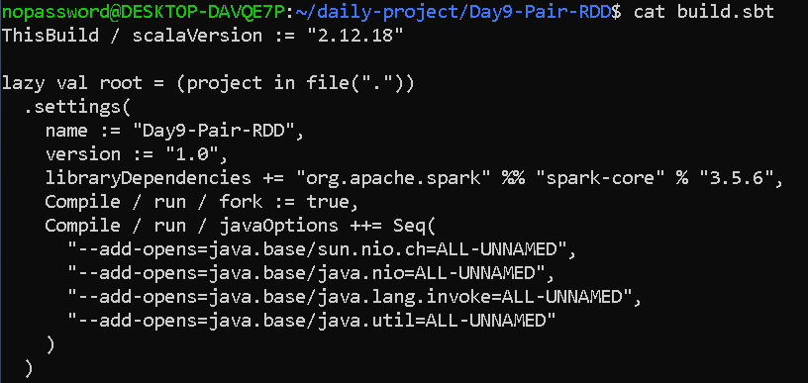

cat src/main/scala/Day9PairRDD.scala
import org.apache.spark.{SparkConf, SparkContext}

object Day9PairRDD {

def main(args: Array[String]): Unit = {

val conf = new SparkConf()
.setAppName("Day9-Pair-RDD")
.setMaster("local[*]")
.set("spark.serializer", "org.apache.spark.serializer.JavaSerializer")

val sc = new SparkContext(conf)

sc.setLogLevel("WARN")

// --------------------------------------------------
// 1. Create Key-Value Pair RDD
// --------------------------------------------------

val sales = Seq(
("Laptop", "Electronics", 2, 50000),
("Mouse", "Electronics", 5, 500),
("Keyboard", "Electronics", 3, 1500),
("Laptop", "Electronics", 1, 50000),
("Chair", "Furniture", 4, 3000),
("Table", "Furniture", 2, 7000),
("Chair", "Furniture", 2, 3000),
("Phone", "Electronics", 3, 25000)
)

val salesRDD = sc.parallelize(sales)

println("\n========== ORIGINAL SALES DATA ==========")
salesRDD.collect().foreach(println)

// --------------------------------------------------
// 2. Revenue by Product using reduceByKey
// --------------------------------------------------

val productRevenue = salesRDD
.map {
case (product, department, quantity, price) =>
(product, quantity * price)
}
.reduceByKey(_ + _)

println("\n========== REVENUE BY PRODUCT ==========")
productRevenue.collect().sortBy(_._1).foreach(println)

// --------------------------------------------------
// 3. Revenue by Department using reduceByKey
// --------------------------------------------------

val departmentRevenue = salesRDD
.map {
case (product, department, quantity, price) =>
(department, quantity * price)
}
.reduceByKey(_ + _)

println("\n========== REVENUE BY DEPARTMENT ==========")
departmentRevenue.collect().sortBy(_._1).foreach(println)

// --------------------------------------------------
// 4. mapValues Example
// --------------------------------------------------

val productQuantities = salesRDD
.map {
case (product, department, quantity, price) =>
(product, quantity)
}

val doubledQuantities = productQuantities.mapValues(q => q * 2)

println("\n========== MAPVALUES - DOUBLED QUANTITIES ==========")
doubledQuantities.collect().foreach(println)

// --------------------------------------------------
// 5. groupByKey Example
// --------------------------------------------------

val groupedProducts = productQuantities.groupByKey()

println("\n========== GROUPBYKEY - QUANTITIES BY PRODUCT ==========")

groupedProducts
.collect()
.sortBy(_._1)
.foreach {
case (product, quantities) =>
println(product + " -> " + quantities.mkString(", "))
}

// --------------------------------------------------
// 6. Compare reduceByKey and groupByKey
// --------------------------------------------------

val startReduce = System.nanoTime()

val reduceResult = productQuantities
.reduceByKey(_ + _)
.collect()

val endReduce = System.nanoTime()

val reduceTime = (endReduce - startReduce) / 1e6

val startGroup = System.nanoTime()

val groupResult = productQuantities
.groupByKey()
.mapValues(_.sum)
.collect()

val endGroup = System.nanoTime()

val groupTime = (endGroup - startGroup) / 1e6

println("\n========== PERFORMANCE COMPARISON ==========")

println("reduceByKey result:")
reduceResult.sortBy(_._1).foreach(println)

println(f"reduceByKey execution time: $reduceTime%.3f ms")

println("\ngroupByKey result:")
groupResult.sortBy(_._1).foreach(println)

println(f"groupByKey + mapValues execution time: $groupTime%.3f ms")

// --------------------------------------------------
// 7. Bank Transaction Scenario
// --------------------------------------------------

val transactions = Seq(
("ACC101", 5000.0),
("ACC102", 3000.0),
("ACC101", 2500.0),
("ACC103", 7000.0),
("ACC102", 1500.0),
("ACC101", 1000.0),
("ACC103", 2000.0),
("ACC104", 4500.0)
)

val transactionRDD = sc.parallelize(transactions)

val accountTotals = transactionRDD
.reduceByKey(_ + _)

println("\n========== BANK TRANSACTIONS BY ACCOUNT ==========")

accountTotals
.collect()
.sortBy(_._1)
.foreach {
case (account, amount) =>
println(f"$account -> Rs. $amount%.2f")
}

// --------------------------------------------------
// 8. Number of Partitions
// --------------------------------------------------
println("\n========== PARTITION INFORMATION ==========")
println("Sales RDD partitions: " + salesRDD.getNumPartitions)
println("Transaction RDD partitions: " + transactionRDD.getNumPartitions)

sc.stop()
}
}

OUTPUT—
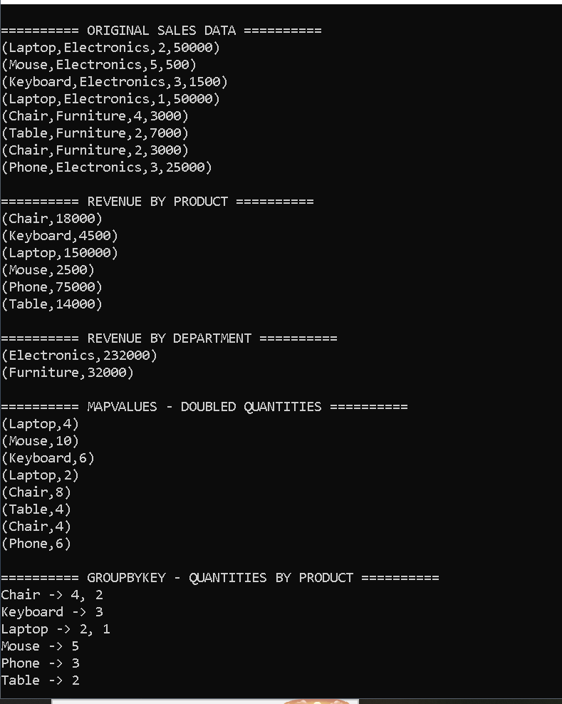

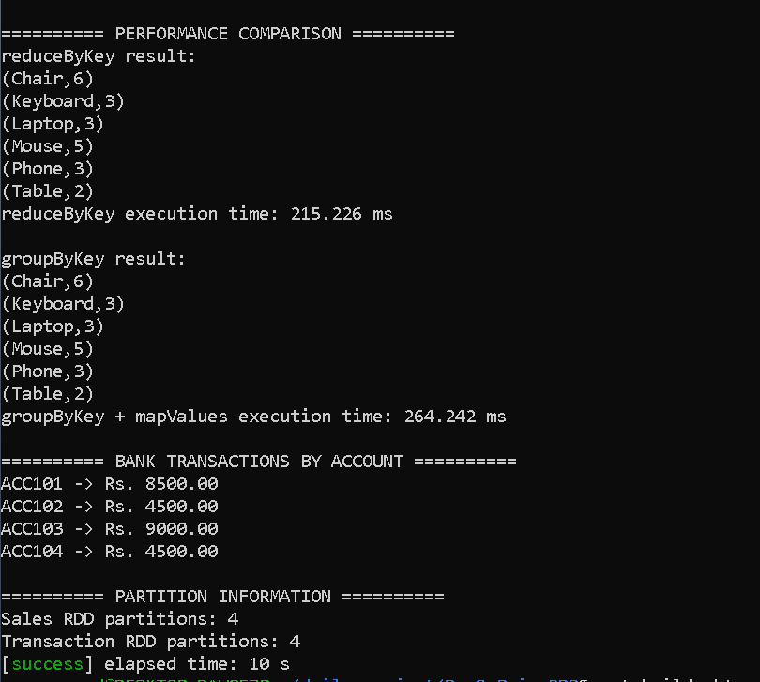
My Day 9 assignment is based on Pair RDDs in Apache Spark. A Pair RDD contains data in key-value format. I first created sales data containing product, department, quantity and price and converted it into an RDD using parallelize. I then calculated revenue by multiplying quantity and price. I used the product as the key and reduceByKey to calculate total revenue for each product. I repeated the same concept using department as the key to calculate department-wise revenue.
I also demonstrated mapValues, which modifies only the values while keeping the keys unchanged, and groupByKey, which groups all values belonging to the same key. I compared reduceByKey and groupByKey and learned that reduceByKey is generally more efficient for aggregation because it can combine values locally before shuffle.
Finally, I implemented a bank transaction scenario where Account ID is the key and transaction amount is the value. Using reduceByKey, I calculated the total transaction amount for each account. This demonstrates a practical application of Pair RDDs for distributed aggregation."

